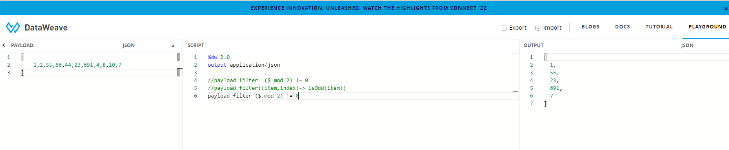

Input :

[

1,2,55,66,44,23,691,4,8,10,7

]

Dw Script:

%dw 2.0

output application/json

---

//payload filter ($ mod 2) != 0

//payload filter((item,index)-> isOdd(item))

payload filter ($ mod 2) != 0

output:

[

1,

55,

23,

691,

7

]